**Low Elevation Coastal Zone**

**Urban-Rural Population and Land Area Estimates**

**(1990, 2000, 2010, 2100)**

#### Version 2

#### December 2013

**Socioeconomic Data and Applications Center (SEDAC)**

**Center for International Earth Science Information Network (CIESIN)**

**Columbia University**

**61 Route 9W**

**P.O. Box 1000**

**Palisades, NY 10964**

**Phone: 1 (845) 365-8920  
FAX: 1 (845) 365-8922**

**Please address comments to SEDAC User Services**

<http://sedac.uservoice.com/knowledgebase/topics/21155>

This document outlines the basic methodology and data sets used to construct the Low Elevation Coastal Zone Urban-Rural Population and Land Area Estimates version 2 data release. Please see the disclaimer and use restrictions at the end of the document, as well as the suggested citation below. **Users are encouraged to review important uncertainty information in Section II on data processing and methodology.** We appreciate feedback regarding this data set, such as suggestions, discovery of errors, difficulties in using the data, and format preferences.

**Recommended citation:**

Center for International Earth Science Information Network (CIESIN)/Columbia University. 2013. Low Elevation Coastal Zone: Urban-Rural Population and Land Area Estimates Version 2. Palisades, NY: NASA Socioeconomic Data and Applications Center (SEDAC). http://sedac.ciesin.columbia.edu/data/set/lecz-urban-rural-population-land-area-estimates-v2. Accessed DAY MONTH YEAR

Contents

I. Introduction 2

II. Data Processing and Methodology 2

III. How to Use Pivot Tables in Excel 12

IV. Data Filters 13

V. Map Gallery 14

VI. Appendix 15

VII. Acknowledgments 15

VIII. Disclaimer 15

IX. References 16

# Introduction

The Low Elevation Coastal Zone (LECZ) Urban-Rural Population and Land Area Estimates Version 2 data set provides continent-level and country-level estimates of land area (square kilometers) and urban, rural, and total population (counts) for 202 statistical areas (countries and other UN recognized territories). Country-level summaries of the first version of the data were released in 2006; the original 1 km spatial data product may be downloaded via http://sedac.ciesin.columbia.edu/data/set/lecz-urban-rural-population-estimates-v1. The methodology used to construct those data and the analysis of key findings is described in McGranahan et al. (2007). The basic concept remains unchanged here, but the main revisions in constructing LECZv2 are 1) improvements to the spatial resolution and 2) the inclusion of a fuller-range of elevation criteria in the zones themselves. Refinements to the spatial resolution also necessitated corrections to the coastlines of the administrative boundary data of the census geography. The methods for these revisions are discussed herein.

In this revised dataset, population and land area estimates are subdivided by elevation zone as derived from Shuttle Radar Topographic Mission (SRTM) elevation data at two resolutions: ~90m and ~1km. 90m estimates can be filtered by geo-region, geo-subregion, income group, and lending category for theme-specific statistics.

**Downloads**

The data are available in tabular (spreadsheet) format as downloadable Excel formatted files or as comma separated value (csv) files of raw data from the LECZ web site (http://sedac.ciesin.columbia.edu/data/set/lecz-urban-rural-population-land-area-estimates-v2).

# Data Processing and Methodology

**Overview – Basic Methods**

Estimates for populations at risk can vary substantially based on the input data sets used (Mondal and Tatem 2012). Elevation data were therefore processed at two resolutions, 3 arc seconds (~90m) and 30 arc seconds (~1km), to provide users with a range in population estimates in LECZs. For the 90m resolution data set, population inputs from Gridded Rural-Urban Mapping Project, version 1 (GRUMPv1) and from Gridded Population of the World, version 3 (GPWv3) were gridded at a 3 arc second (~90m) resolution and overlaid with elevation data derived from the SRTM 90 meter data set to produce population and land area estimates in 1m, 3m, 5m, 7m, 9m, 10m, 12m, and 20m low elevation coastal zones. Population and land area estimates are also provided for areas greater than 20m, which includes all non-contiguous coastal pixels, and for total country and total continent levels. For the 1km resolution data set, population inputs from GRUMPv1 and GPWv3 were overlaid with SRTM elevation data generalized at a 1km resolution to produce population and land area estimates in a 10m low elevation coastal zone.

**Specific Methods**

Elevation data

Elevation data were preprocessed by ISciences LLC to isolate elevation values of less than or equal to 20m that were contiguous to the SRTM coastline. Pixels with values greater than 20m as well as those non-contiguous to coastlines were recoded into their own class interval. Pixels seaward of the SRTM coastline were recoded as ocean. Voids in the SRTM 3 arc second digital elevation model were filled using the best available data from two other sources: the *National Elevation Data set* (NED) published by the US Geological Survey (USGS); and, the ISciences *SRTM30 Enhanced Global Map* data set.

It is important to emphasize that this work was constrained by the spatial accuracy limitations of globally-available data sets, so there remain uncertainties that would need to be resolved by local-level assessments. Among other things, it must be recognized that sea level rise will not be consistent globally, but will be affected by coastal bathymetry and local topography and tides, while the extent of areas periodically submerged will also be affected by storm surge (Strauss et al. 2012, Tebaldi et al. 2011). In terms of the elevation data used to define sea level, SRTM has a vertical accuracy in low slope areas of approximately +/- 4-5 meters (Gorokhovich and Voustaniak 2006). As a result, certain low-lying island nations in the LECZ data set might have higher elevation ceilings than are expected. These errors are present in the SRTM data set and are due to the limitations of the SRTM vertical accuracy and not due to data processing for the LECZ. Also, the SRTM elevation data cannot depict sea level at different tide states. A further limitation is the quality of the SRTM elevation data in mangroves or other heavily forested coastal areas. Currently, all satellite-derived (SRTM and ASTER) global digital elevation models generally capture the elevation of the canopy cover and not the ground level, thereby overestimating the elevation in these zones and underestimating the exposure of sites in those areas to sea level rise.

These considerations should be taken into account by users. As such, the LECZ data set is most valid at the country level. Applications at a finer resolution should be made with caution and supplemented with additional data validation.

Coastal reconciliation

In contrast to LECZv1, and compelled by the improved resolution of the LECZ data, the coastlines of the GRUMPv1 and GPWv3 input administrative units were spatially adjusted to match the 3 arc second SRTM coastline, which has greater resolution and accuracy. The appendix lists the countries where GPWv3 was used as input data. The process of coastline reconciliation was necessary so that the proportional allocation of population would not result in the erroneous placement of people in areas defined as oceans by the SRTM data set. The underlying boundary data with population attributes (used in GRUMPv1 and GPWv3) come from more than 200 national statistical offices and are of variable spatial accuracy. The following workflow describes how we adjusted coastlines by means of an automated procedure for the GRUMPv1 input data. The same workflow was also used for the GPWv3 input data.

Step 1

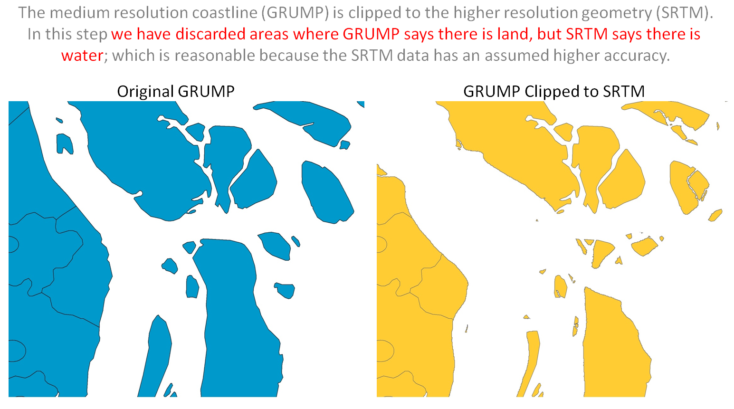

Step 2

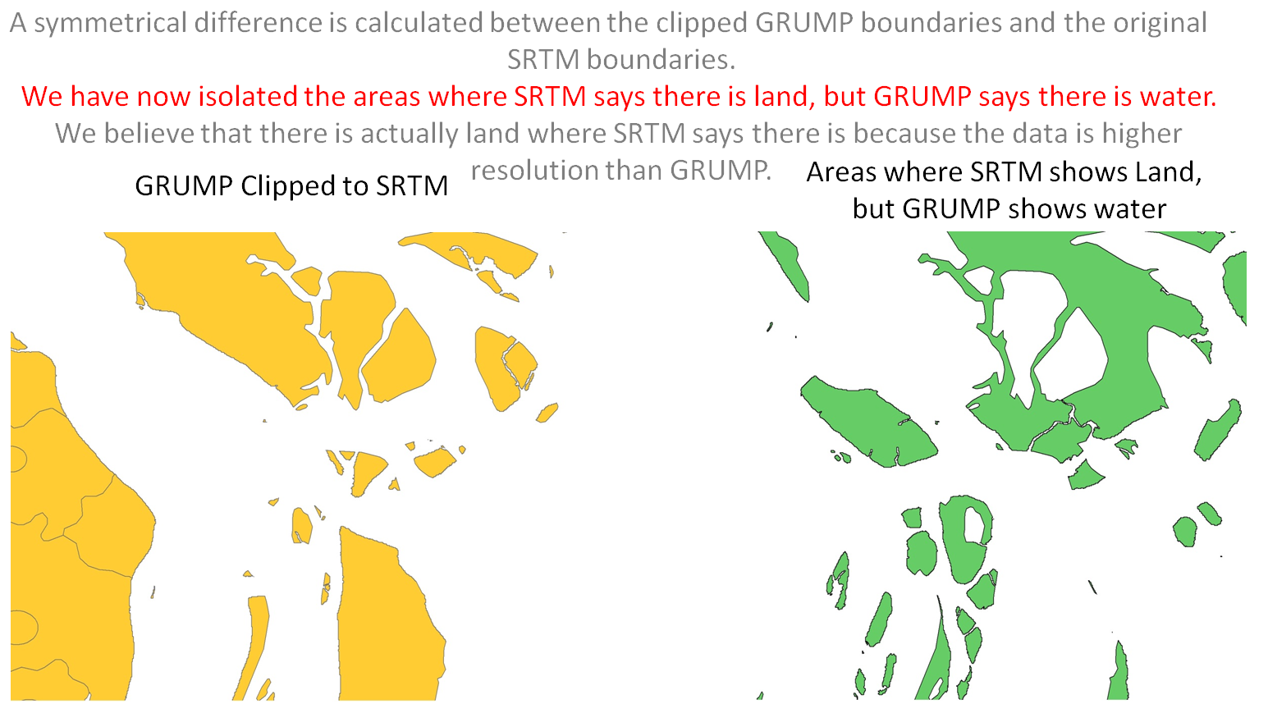

Step 3

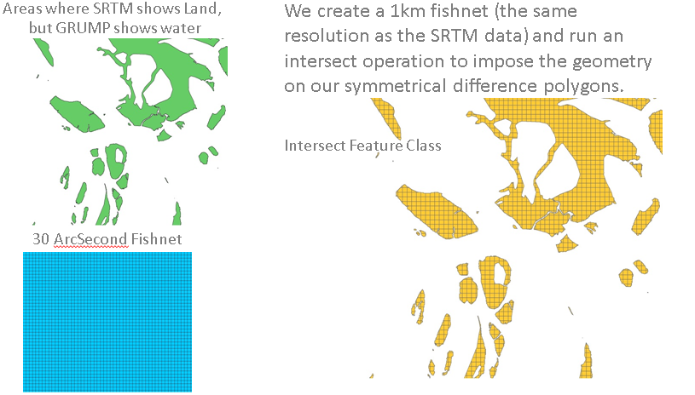

Step 4

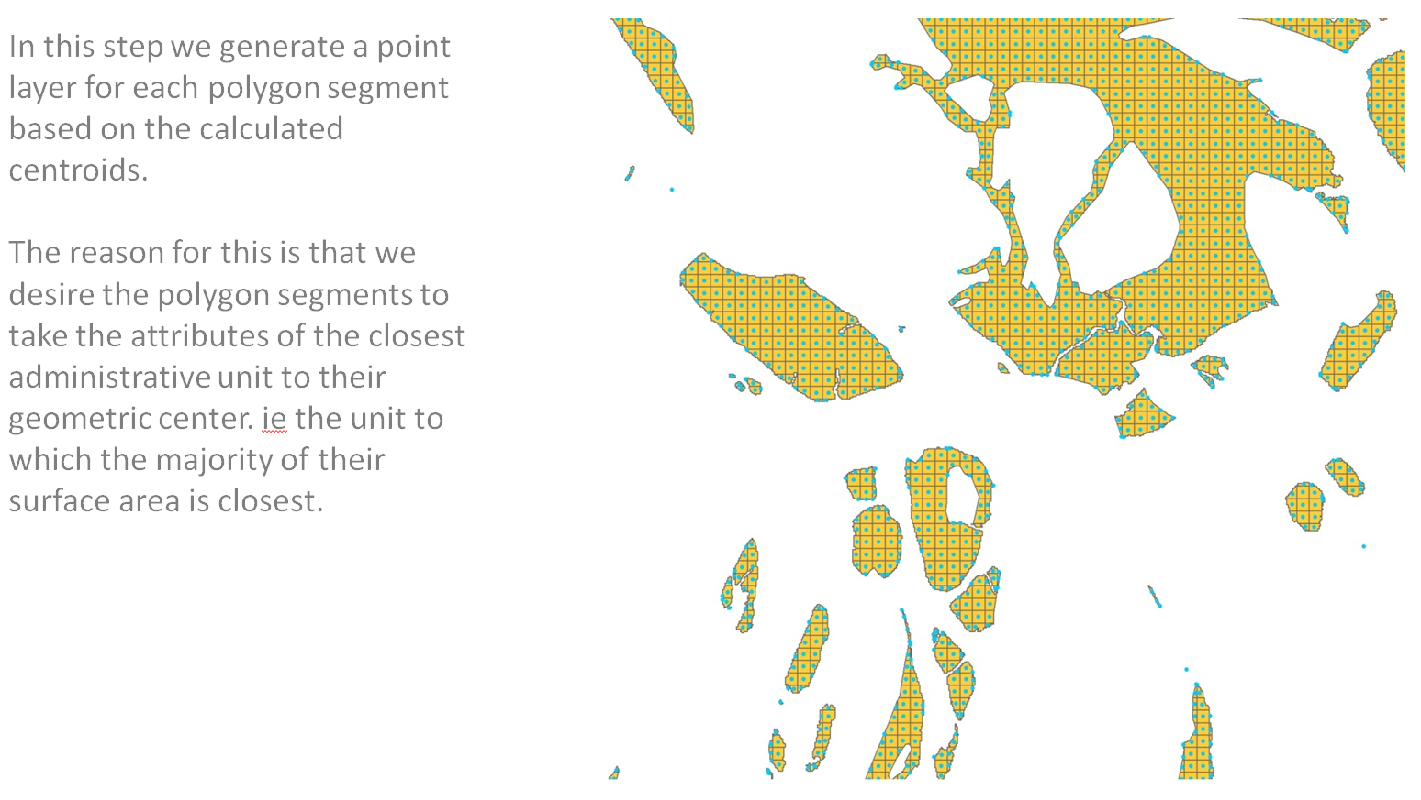

Step 5

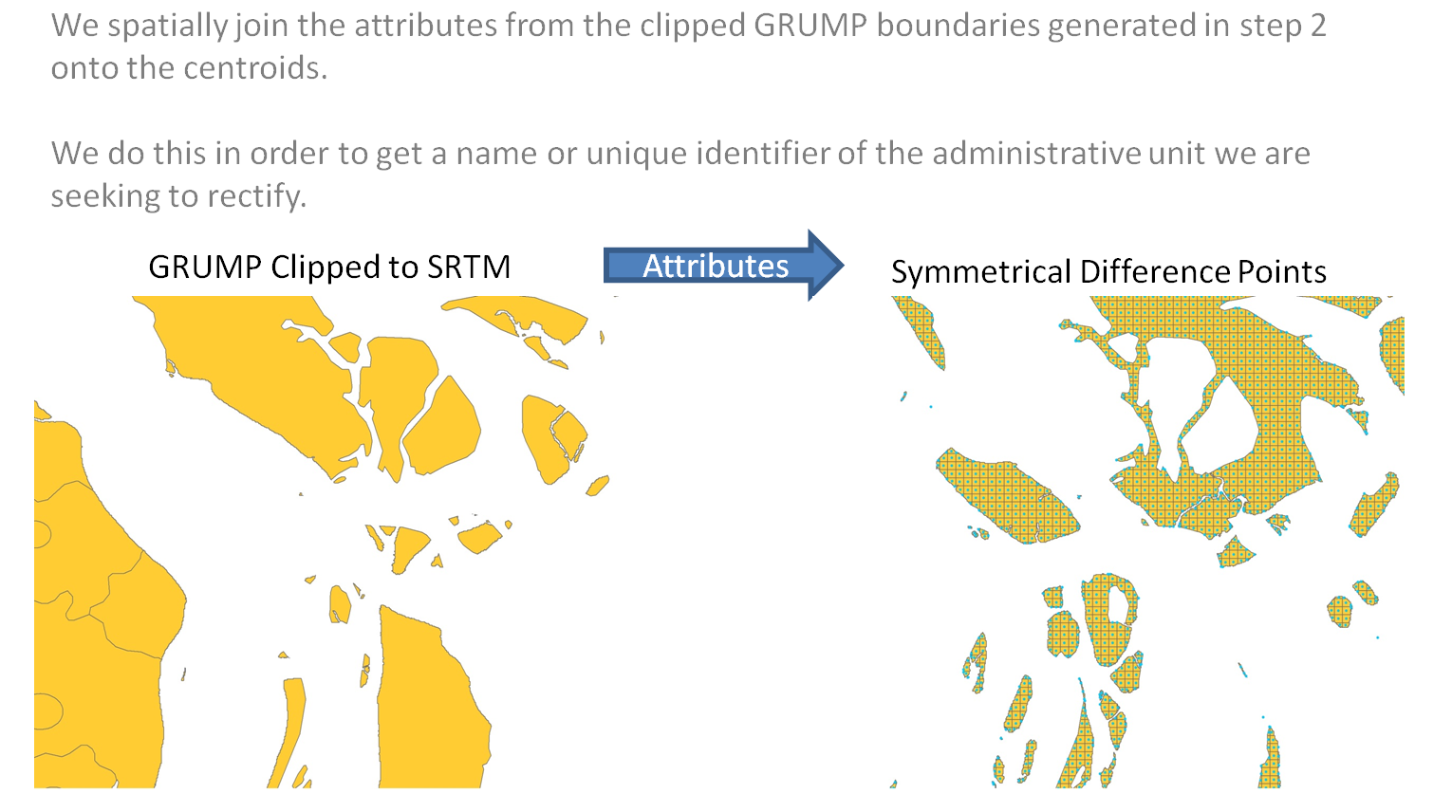

Step 6

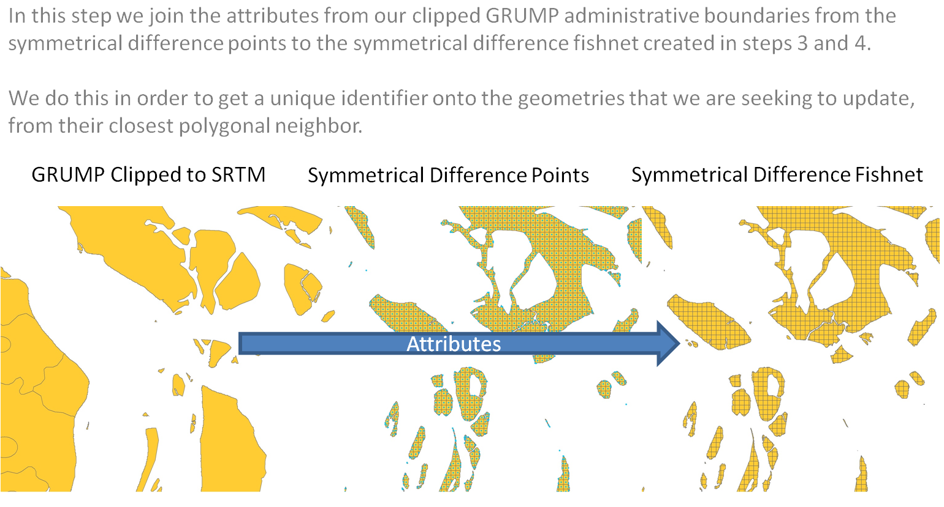

Step 7

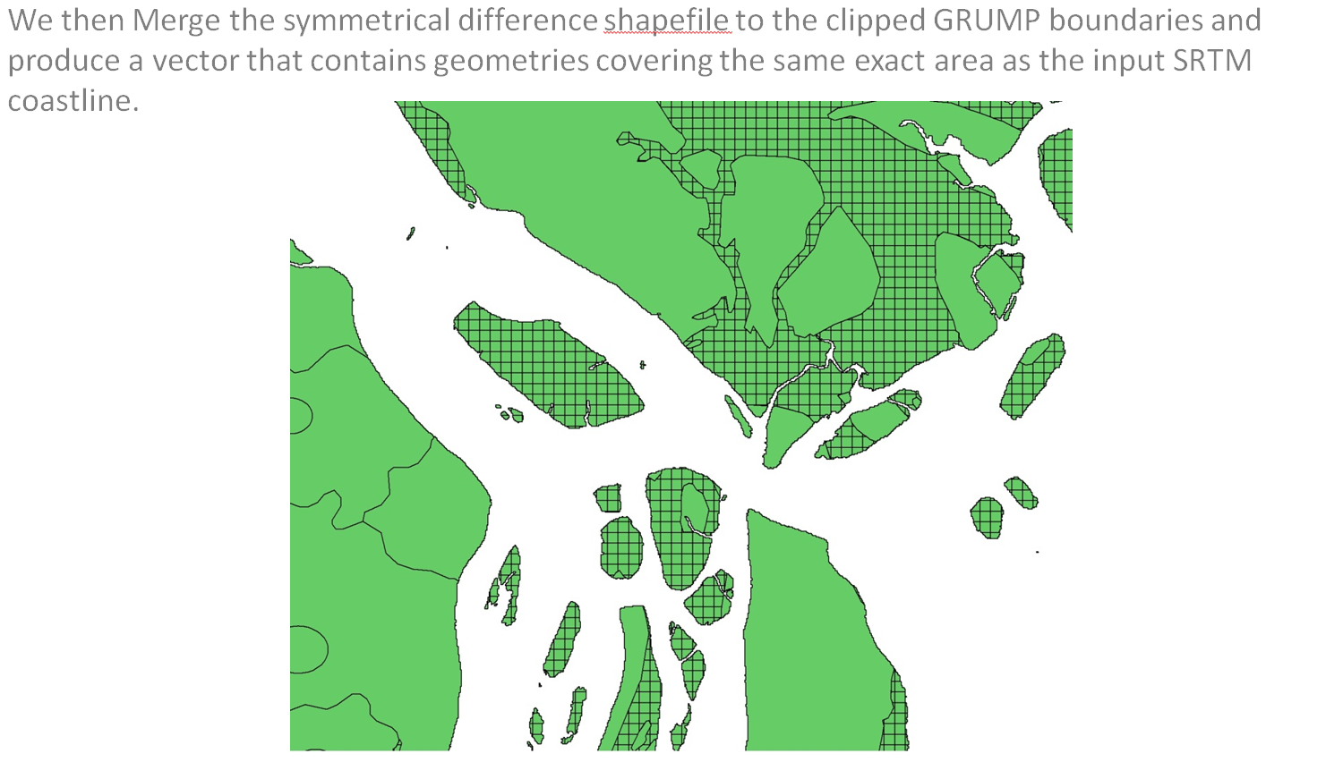

Step 8

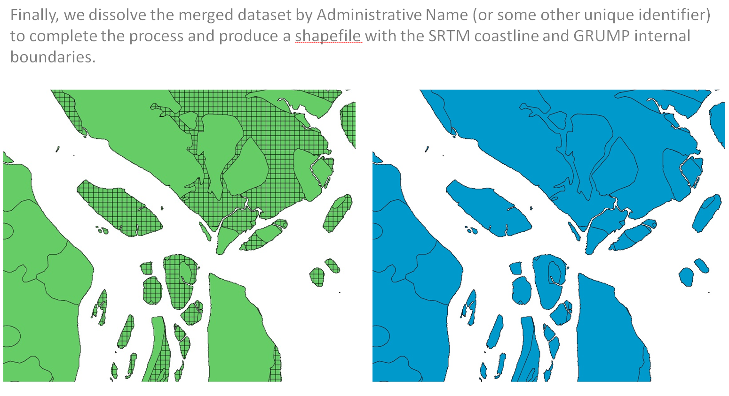

Distributing Coastal Population

In order to provide estimates of populations in low elevation coastal zones, it was first necessary to proportionally allocate census estimates in those areas. The GRUMPv1 and GPWv3 data sets allocated population into 30 arc second (~1km) grid cells globally; however, the population needed to be reallocated due to the coastal adjustment. The GRUMPv1 and GPWv3 population inputs were allocated again, both at a 30 arc second and at a 3 arc second resolution to make the data compatible with both resolutions of SRTM elevation data.

Proportional allocation is dependent on input geographic geometries and areal population estimates. Land area was calculated on a per pixel basis by first determining the total land area of a grid cell, and then subtracting the surface water area in that cell to find a final grid cell area. These final grid cell areas were aggregated to determine the total land area of a given administrative unit. The population density of a unit was calculated by dividing the population count census estimate for a given unit by its land area. Population could then be allocated into individual grid cells by multiplying the unit population density by the individual grid cell’s land area. GRUMPv1 population inputs account for urban and rural areas within a given enumeration area and allocate population in a greater proportion to the urban areas.

It is important to note that urban and rural designations for all countries are based on GRUMPv1 urban extent boundaries circa 1995. The urban extent grids distinguish urban and rural areas based on a combination of population counts (persons), settlement points, and the presence of Nighttime Lights. Urban areas are defined as the contiguous lighted cells from the Nighttime Lights or approximated urban extents based on buffered settlement points for which the total population is greater than 5,000 persons. These extents are not redefined for 1990, 2010, or 2100; instead, for all years the urban-rural structure is assumed to be the same as in 2000. For more information on the GRUMPv1 methodology, please see the documentation by Balk et al. (2004).

Population Estimates for 1990 and 2000

GRUMPv1 and GPWv3 input data include population estimates for the years 1990 and 2000. These estimates were compiled from census data. Estimates in LECZv1 were based on a previous version of the GRUMP data, GRUMP alpha, as well as on GPWv3. The appendix lists the countries where GPWv3 was used as input data.

Population Estimation for 2010

Estimates for 2010 were developed by applying urban and rural growth rates from the United Nations World Urbanization Prospects 2011 Revision (United Nations, 2012), to the GRUMPv1 and GPWv3 2000 estimates. The UN provides national urban and rural growth rate estimates, and estimates of population in five year intervals. To produce the 2010 population estimate for the LECZ data set, GRUMPv1 and GPWv3 year 2000 population estimates were adjusted incrementally to year 2005, and then to year 2010 based on the UN growth rates. Finally, the total national population was adjusted to match the estimates provided by the World Urbanization Prospects.

Population Estimation for 2100

Extrapolated population counts for the year 2100 were calculated using growth rates derived from the IIASA GGI Downscaled Spatially Explicit Socio-Economic Scenario Data (Grubler et al. 2007). IIASA provides global population estimates at a 0.5 degree resolution for years 2000 to 2100 in 10 year increments. A 100 year growth rate was determined on a per pixel basis by comparing the IIASA population counts for the year 2000 to the year 2100, such that:

GROWTHRATE = (POPCOUNT2100IIASA – POPCOUNT2000IIASA) / POPCOUNT2000IIASA

Once the global growth rate grid was produced, it was possible to apply the growth rates to GRUMPv1 and GPWv3 year 2000 population counts on a pixel by pixel basis. This was accomplished through map algebra where:

POPCOUNT2100LECZ = POPCOUNT2000GRUMP/GPW + (POPCOUNT2000GRUMP/GPW * GROWTHRATE)

**Data Validation**

Population and land area estimates for the year 2000 from the 90m and 1km data sets were compared against the previous 1km version of LECZ Urban-Rural estimates (McGranahan et al., 2007) and against total country values of population and land area reported by the CIA Factbook (2013). Estimates were corrected if known processing errors were found. The remaining differences in population and land area estimates between the two data sets stem largely from the differences in the resolution of input data, and for countries where the GRUMP dataset was used as input, an earlier version, GRUMP alpha, was used for LECZv1. The estimates herein are based on GRUMPv1.

**Comparison between 90m and 1km resolution data sets**

The accuracy of population and land area estimates are affected by 1) the resolution of the input census units, 2) the spatial resolution of the elevation raster (i.e. ~90m or ~1km), and 3) the interaction of the two. We include two sets of estimates in order to provide users with a range in population and land area estimates for the LECZ that acknowledges the uncertainty associated with the interaction multiple resolutions in input data. We describe these uncertainties in the following sections.

1) The resolution of the input census units

In proportionally allocated raster data, the precision and accuracy of individual grid cells is directly related to the size of the input areal units associated with a country’s census, and the cell size of the derived gridded data. Coarse-resolution census inputs (such as first-order administrative units) can introduce uncertainty into pixel estimates of population (Mondel and Tatum, 2012), especially if the cell size of the derived grid is high resolution. In GRUMPv1 and GPWv3, the size of the subnational administrative boundaries corresponding to the input census estimates varies among countries.

As an example, take the case where the area of a given input census unit is 100km2 and the census reported population of that unit is 25,000 people. If the population estimate of that unit is proportionally allocated at a raster cell resolution of 1km, then the population will be evenly divided into 10,000 pixels, or 2.5 people per pixel. If the same unit is proportionally allocated at a raster cell resolution of ~90m, then the population will be evenly divided into ~ 1,000,000 pixels, or 0.025 people per pixel. In this example, the evaluation of a single pixel at ~90m cell resolution will never produce an accurate accounting of the number of people in that location.

Although this is logically consistent, it has serious implications for analysis. Namely, a cross-tabulation analysis of population by elevation zone at the 1km cell size will capture more population in each intersecting pixel than a 90m analysis would. If the zones in the analysis data are highly precise at 90m, as SRTM elevation data is, then the population in those zones may be underrepresented due to the lack of precision owing to coarse input census units.

2) The spatial resolution of the elevation grid

In areas of heterogeneous topography along the coastline, the 90m grid may capture small, low-lying areas in valley bottoms or at the foot of cliffs. However, the 1km grid estimates the elevation over a larger surface area, and can smooth the topography such that low elevations bordering high elevations will be averaged together and considered moderate elevation. In this case, unlike the example above, the 1km grid provides lower area and population estimates in the LECZ than the 90m grid.

The territory of Saint Helena provides a striking example. In the 1km data set, Saint Helena has zero land area and zero population in the 10m LECZ, while the 90m data set records a population of 862 in the 10m LECZ. In the 90m grid, the low elevation of the town of Jamestown, which lies in a narrow valley, is captured because of the highly resolved cell size (Fig. 1). However, the larger cell size of the 1km grid generalizes the area in favor of the high elevations of the surrounding hills and results in no cells within the LECZ at the 1km resolution.



Figure 1. The town of Jamestown, Saint Helena, located in the James valley. (Image from Wikipedia.)

By contrast, in coastal areas with more homogenous terrain, the larger cell size of the 1km grid results in more area being captured by each grid cell as compared to the 90m grid. The 1 km grid captures more area, and thus a larger share of the population because of the larger size of its pixels. In some cases the LECZ will extend further inland than the 90m grid (Fig. 2). When this occurs, the 1km grid provides higher estimates of the LECZ land area and population relative to the 90m grid.

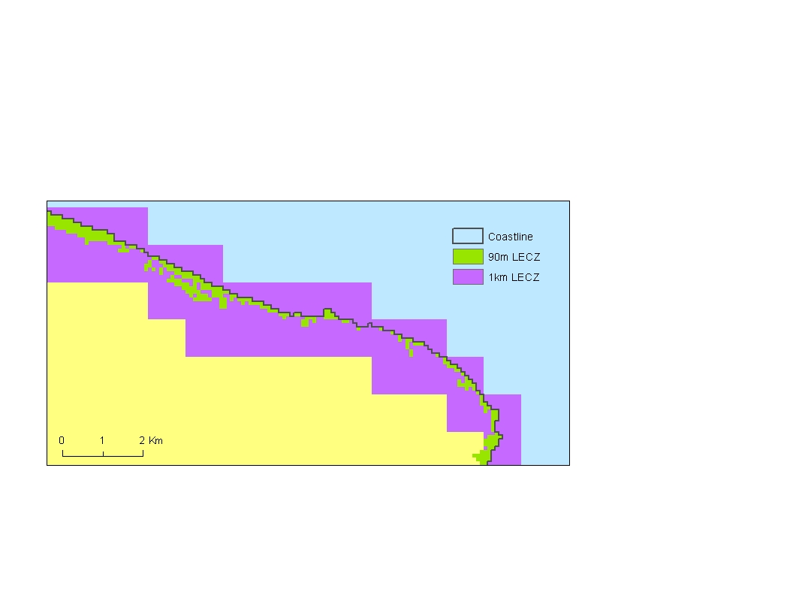

Figure 2. In low-lying coastal areas, the 1km LECZ will extend further inland than the 90m LECZ, due to the larger cell size.

3) The interaction of spatial resolutions

As illustrated in the examples above, 1) the size of input census estimates impacts the accuracy of population count estimates for individual grid cells, and 2) the cell size of LECZ delineations determines the size and number of cells selected for summarization. In countries with relatively large census units, the 1km product may provide more reasonable estimates of population in a LECZ because the relatively coarser grid resolution more closely matches the census input resolution, resulting in more accurate pixel estimates. In countries with very high resolution census inputs, the 90m product may provide more reasonable results because it will capture low elevations in areas with heterogeneous terrain which might be generalized at 1km resolution.

It should be understood that both cases 1 and 2 might occur within a single country as the relative size of census units often varies sub-nationally. In general, densely settled areas tend to have smaller census units. The difference in LECZ land area and population estimates reported by the 1km and 90m products is the result of the balance between these two cases. Again, the inclusion of two sets or estimates is intended to provide users with a range in population and land area estimates for the LECZ that acknowledges the uncertainty associated with the interaction multiple resolutions in input data.

# How to Use Pivot Tables in Excel

In the LECZ database, pivot tables are used to summarize and subdivide tabular data based on user input. This workbook contains three pivot tables created from the LECZ database: one for population and land area counts at the national level, one for population and land area counts in continental aggregations, and a third that compares population counts in the 90m and 1km data sets. The population counts are given for 4 years: 1990, 2000, 2010*, and 2100*

*Filters*

Data displayed in a pivot table can be filtered to a subset, hiding data that do not meet the specified criteria. Multiple filters can be applied at once, to further refine the data. The filter options included in the LECZ data release are the following:

* Elevation Zone
* Country
* Continent
* Urban/Rural designation
* GeoRegion
* GeoSubregion
* Income Group
* Lending Category

Urban/Rural designations are determined by the Gridded Population of the World Version 1 (GRUMPv1) urban extents data set. GeoRegion and GeoSubregion are defined by the United Nations, and Income Group and Lending Category are defined by the World Bank. For more information, see section on data filters.

The color of the filter cell indicates if the filter is in its default state or is activated. Additionally, filters may be flagged if the data has already been subset in such a way that additional filters become redundant or irrelevant.

*Data Exploration*

Pivot tables also have functionality that exposes the data behind summary calculations. By double-clicking on a cell the pivot table creates a new spreadsheet that contains all of the data that generated the value of that cell, allowing for more detailed data exploration.

For more details about how to use pivot tables and how they are created, please reference Microsoft Office's help tools and documentation, or any number of helpful sites on the web.

* **Note:** Population totals for 2010 and 2100 are not based on observed census counts, but rather projections of year 2000 population data through the application of growth rates. For more information, see the methodology description.

# Data Filters

The pivot table offers different ways to group or filter data:

1. *Elevation Zone*

Elevation data used to generate the LECZs come from the a custom digital elevation model derived from NASA’s Jet Propulsion Laboratory Shuttle Radar Topography Mission data processed to 3 arc-seconds, and supplemented with data from the USGS National Elevation Data set (NED) and the ISciences SRTM30 Enhanced Global Map data set where necessary.

Source Information: ISciences (2003), SRTM30 Enhanced Global Map -Elevation/Slope/Aspect (release 1.0), ISciences, LLC, Ann Arbor (based on the raw SRTM data from Jet Propulsion Laboratory).

1. *Country*

The Global Rural-Urban Mapping Project, Version 1 (GRUMPv1) National Boundaries Data Set distinguishes state entities.

1. *Continent*

The Global Rural-Urban Mapping Project, Version 1 (GRUMPv1) National Boundaries Data Set distinguishes state entities by continent.

1. *Urban/Rural Designation*

The Global Rural-Urban Mapping Project, Version 1 (GRUMPv1) urban extent grid distinguishes urban and rural areas based on a combination of population counts (persons), settlement points, and the presence of Nighttime Lights. Areas are defined as urban where contiguous lighted cells from the Nighttime Lights or approximated urban extents based on buffered settlement points for which the total population is greater than 5,000 persons.

Source Information: Center for International Earth Science Information Network (CIESIN), Columbia University; International Food Policy Research Institute (IFPRI); The World Bank; and Centro Internacional de Agricultura Tropical (CIAT). 2011. Global Rural-Urban Mapping Project, Version 1 (GRUMPv1). Palisades, NY: Socioeconomic Data and Applications Center (SEDAC), Columbia University. Available at <http://sedac.ciesin.columbia.edu/data/collection/grump-v1>

1. *Geo Region*

The geographical regions used by the United Nations Statistics Division in its publications and databases. Each country is shown in one region only. Geo Regions refer to the UN’s macro geographical regions, and correspond as closely as possible to continents.

Source Information: United Nations Statistics Division, [http://unstats.un.org/unsd/methods/ m49/m49regin.htm](http://unstats.un.org/unsd/methods/%20m49/m49regin.htm), Updated 20 Sept, 2011. Accessed 13 Aug, 2012.

1. *Geo Subregion*

Within macro geographical groupings, more detailed sub-regions are shown. From the UN: “The assignment of countries or areas to specific groupings is for statistical convenience and does not imply any assumption regarding political or other affiliation of countries or territories by the United Nations.”

Source Information: United Nations Statistics Division, [http://unstats.un.org/unsd/methods/m49 /m49regin.htm](http://unstats.un.org/unsd/methods/m49/m49regin.htm), Updated 20 Sept, 2011. Accessed 13 Aug, 2012.

1. *Income Group*

From the World Bank: "Economies are divided according to 2010 GNI per capita, calculated using the World Bank Atlas method. The groups are: low income, $1,005 or less; lower middle income, $1,006 - $3,975; upper middle income, $3,976 - $12,275; and high income, $12,276 or more."

Source Information: World Bank, <http://data.worldbank.org/about/country-classifications/country-and-lending-groups#South_Asia>, Updated 18 July, 2011. Accessed 13 Aug, 2012.

1. *Lending category*

From the World Bank: "IDA countries are those that had a per capita income in 2010 of less than $1,175 and lack the financial ability to borrow from the International Bank for Reconstruction and Development (IBRD). IDA loans are deeply concessional—interest-free loans and grants for programs aimed at boosting economic growth and improving living conditions. IBRD loans are concessional. Blend countries are eligible for IDA loans because of their low per capita incomes but are also eligible for IBRD loans because they are financially creditworthy."

Source Information: World Bank, <http://data.worldbank.org/about/country-classifications/country-and-lending-groups#South_Asia>, Updated 18 July, 2011. Accessed 13 Aug, 2012.

# Map Gallery

The Low Elevation Coastal Zone Urban-Rural Population and Land Area Estimates Version 1 map collection focuses on several areas of interest displaying data at national and sub-national levels.

Maps are available to be viewed and downloaded at:

<http://sedac.ciesin.columbia.edu/data/set/lecz-low-elevation-coastal-zone/maps>

# Appendix

The following is a list of countries and other UN recognized territories where GPWv3 was used as the input data for population estimates. GRUMPv1 inputs were used for all remaining countries not listed below.

|  |
| --- |
| Antigua and Barbuda |
| Aruba |
| Barbados |
| Bermuda |
| British Virgin Islands |
| Cayman Islands |
| Cyprus |
| France |
| Gibraltar |
| Guam |
| Holy See |
| Honduras |
| Hong Kong |
| Hungary |
| Indonesia |
| Japan |
| Kenya |
| Macao |
| Malawi |
| Maldives |
| Malta |
| Monaco |
| Montserrat |
| Nauru |
| Niue |
| Norfolk Island |
| Philippines |
| Pitcairn |
| Poland |
| Portugal |
| San Marino |
| Seychelles |
| Singapore |
| Slovakia |
| Slovenia |
| South Africa |
| Spain |
| Tokelau |
| Tuvalu |
| U.S. Virgin Islands |
| Uganda |
| United States |
| Viet Nam |
| Wallis and Futuna |

# Acknowledgments

Funding for this data set was provided under the U.S. National Aeronautics and Space Administration (NASA) Socioeconomic Data and Applications Center (SEDAC) contract NNG08HZ11C to the Center for International Earth Science Information Network (CIESIN) of Columbia University.

We would like to extend special thanks to ISciences LLC, which provided the custom digital elevation model derived from their SRTM30 Enhanced Global Map and other sources, and Deborah Balk of CUNY’s Institute for Demographic Research for her assessment of working versions of the data and invaluable advice.

Prototype work on this assessment was completed under a contract with the National Intelligence Council.

# Disclaimer

CIESIN provides this data without any warranty of any kind whatsoever, either express or implied. CIESIN shall not be liable for incidental, consequential, or special damages arising out of the use of any data provided by CIESIN. No third-party distribution of all or parts of this data set are permitted without permission.

These data are for noncommercial use; commercial use is not permitted without explicit permission. Additionally, users of the data should acknowledge CIESIN as the source used in the creation of any reports, publications, new data sets, derived products, or services resulting from their use. CIESIN also requests reprints of any publications acknowledging CIESIN as the source and requests notification of any redistribution efforts. The Trustees of Columbia University in the City of New York hold the copyright on data created at CIESIN. CIESIN obtains permissions to disseminate data produced by others. Intellectual property rights and permissions associated with each particular data set are specified in the documentation of the data.

# References

Balk,D., F. Pozzi, G. Yetman, U. Deichmann, and A. Nelson.2004. *The distribution of people and the dimension of place: Methodologies to improve the global estimation of urban extents*. Available at [http://sedac.ciesin.columbia.edu/ gpw/docs/UR_paper_webdraft1.pdf](http://sedac.ciesin.columbia.edu/%20gpw/docs/UR_paper_webdraft1.pdf)

CIA World Factbooks. 2013. "Population (2000) by country", 18 December 2003 to 28 March 2011. Retrieved from <http://www.nationmaster.com/red/graph/peo_pop-people-population&date=2000&b_printable=1>

Gorokhovich, Y. and A. Voustianiouk. 2006. Accuracy assessment of the processed SRTM-based elevation data by CGIAR using field data from USA and Thailand and its relation to the terrain characteristics. *Remote Sensing of Environment* 104:409–415.

Center for International Earth Science Information Network (CIESIN), Columbia University; International Food Policy Research Institute (IFPRI); The World Bank; and Centro Internacional de Agricultura Tropical (CIAT). 2011. Global Rural-Urban Mapping Project, Version 1 (GRUMPv1). Palisades, NY: NASA Socioeconomic Data and Applications Center (SEDAC), Columbia University. Available at <http://sedac.ciesin.columbia.edu/data/collection/grump-v1>

Center for International Earth Science Information Network (CIESIN) Columbia University, and Centro Internacional de Agricultura Tropical (CIAT). 2005. Gridded Population of the World, Version 3 (GPWv3): Population Density Grid. Palisades, NY: NASA Socioeconomic Data and Applications Center (SEDAC). Available at <http://sedac.ciesin.columbia.edu/data/set/gpw-v3-population-density>

Grübler, A., B. O'Neill, K. Riahi, V. Chirkov, A. Goujon, P. Kolp, I. Prommer, S. Scherbov, and E. Slentoe. 2007. Regional, national, and spatially explicit scenarios of demographic and economic change based on SRES. *Technological Forecasting and Social Change* 74(7):980-1029.

McGranahan, G., D. Balk, and B. Anderson. 2007. Low Elevation Coastal Zone (LECZ) Urban-Rural Population Estimates, Global Rural-Urban Mapping Project (GRUMP), Alpha Version. Palisades, NY: NASA Socioeconomic Data and Applications Center (SEDAC). http://sedac.ciesin.columbia.edu/data/set/lecz-low-elevation-coastal-zone.

Mondal, P., and A.J. Tatem. 2012. Uncertainties in measuring populations potentially impacted by sea level rise and coastal flooding. *PLoS ONE* 7(10): e48191.

Strauss, B., R, Ziemlinski, J. Weiss, and J. Overpeck. 2012. Tidally-adjusted estimates of topographic vulnerability to sea level rise and flooding for the contiguous United States. *Environmental Research Letters* 7 014033.

Tebaldi, C., B. Strauss, C. Zervas. 2012. Modelling sea level rise impacts on storm surges along US coasts. *Environmental Research Letters* 7 014032.

United Nations, Department of Economic and Social Affairs, Population

Division. 2012. *World Urbanization Prospects: The 2011 Revision* CD-ROM Edition. POP/DB/WUP/Rev.2011/1/F1, POP/DB/WUP/Rev.2011/1/F6, and POP/DB/WUP/Rev.2011/1/F7.